Name__Samuel Beal Mark _____________________/50

## I really feel like me and a lot of other students are a bit lost with this class right now with some of this stuff, especially with the lecture covering this entire document being Thursday, and having rushed through it all.

The UML tool you suggested also doesn’t have a working website anymore, and I couldn’t find

good tools for free for this project.

## Brief introduction __/3

Lighting and Shadows. Essentially I will be adding light in some sort of way to the map so that edges and corners blend in, adding a more natural look to the game, and to make it look good.

## Use case diagram with scenario __14

### Use Case Diagrams

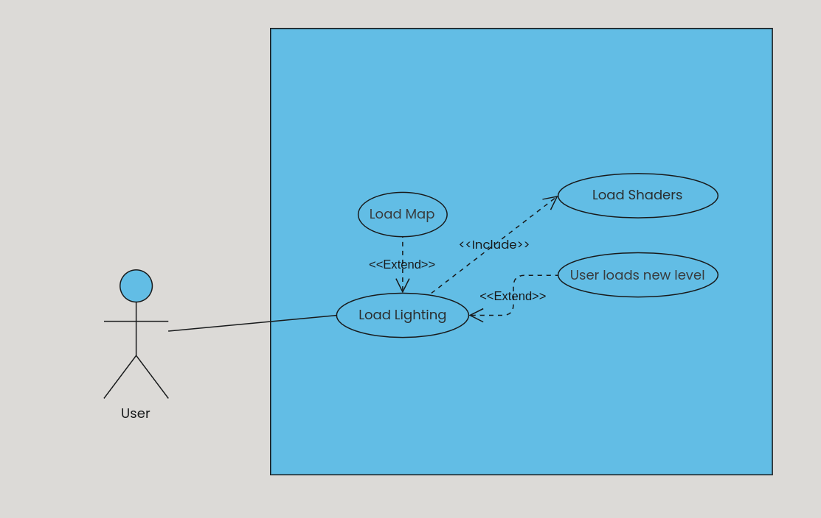

### Scenarios

**Name:** Load Lighting

**Summary:** User loads into a new level and lighting is loaded into the map.

**Actors:** User

**Preconditions:** Map has been loaded and the user starts a level.

**Basic sequence:**

**Step 1:** User loads a level

**Step 2:** Map is loaded

**Step 3:** Load Lighting

**Exceptions:**

**Step 1:** Map should be loaded without lighting

**Step 2:** User loads a new level and the map isn’t loaded yet.

**Post conditions:** Lighting is loaded.

**Priority:** 3*

## Data Flow diagram(s) from Level 0 to process description for your feature _______14

[Get the Level 0 from your team. Highlight the path to your feature]

### Data Flow Diagrams

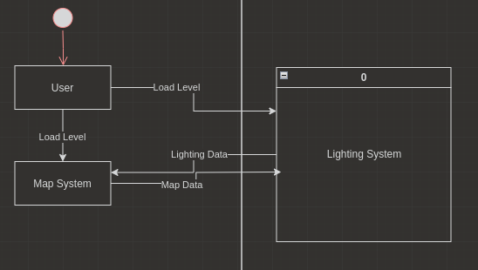

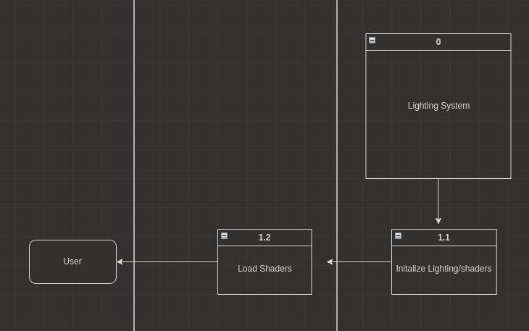

### Process Descriptions

Initialize Lighting*:

Load images, Shader packages, and any other needed data

Set variable names and values

Load Shaders*:

WHILE we are running the game,

update_player_view() // data needed for update_shaders

update_shaders()

reload all packages and data into respective locations

END WHILE

## Acceptance Tests ________9

[Describe the inputs and outputs of the tests you will run. Ensure you cover all the boundary cases.]

**Lighting Feature**

Run features in various scenarios with the map a number of times. Test it by visuals and using different percentages of lighting/opacity/strength type thing.

| Input | Notes on Visuals |
| --- | --- |
| 50% | Interesting amount of lighting, possibly overly bright |
| 100% | Sun blinds and makes it impossible to see anything but white |
| 10% | Shadow like, good for corners. |
| 3% | Very difficult to see but could be used for main area |
|  |  |

## Timeline _________/10

### Work items

| Task | Duration (PWks) | Predecessor Task(s) |
| --- | --- | --- |
| 1. Requirements Collection | 5 | - |
| 2. Map Design | 5 | 1 |
| 3. Level Design | 5 | 1 |
| 4. Shader Design | 2 | 2, 3 |
| 5. User Documentation | 2 | 6 |
| 6. Programming | 5 | 2,3,4 |
| 7. Testing | 2 | 6 |
| 8. Installation | 1 | 5, 7 |

### Pert diagram

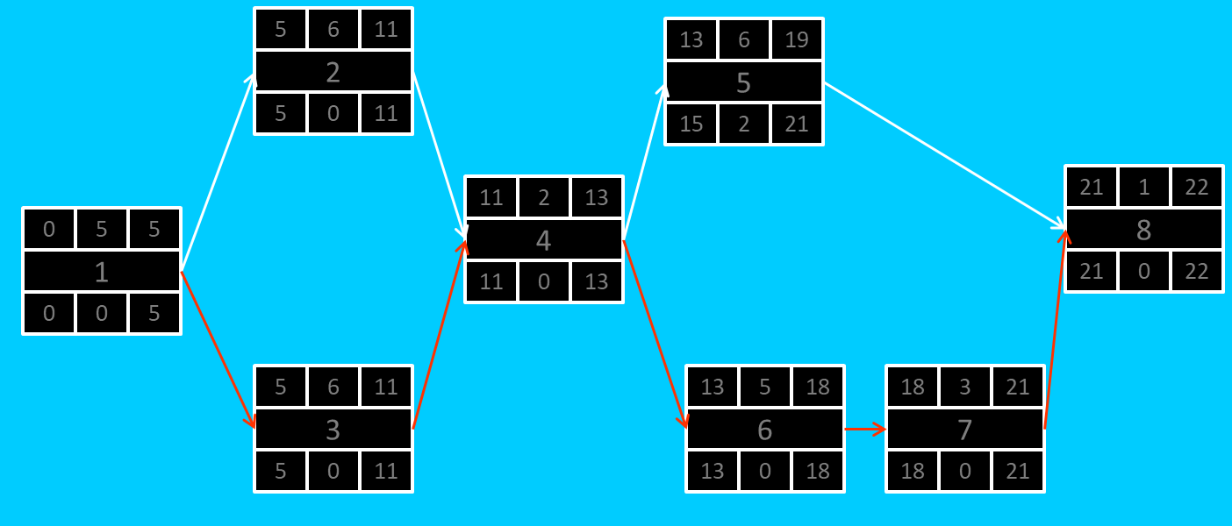

I couldn’t find a website to make a proper pert chart as the one above for free, and the UML website is broken. I found one for tasks at least but it didn’t seem quite capable simply to add in the 6 boxes of numbers.

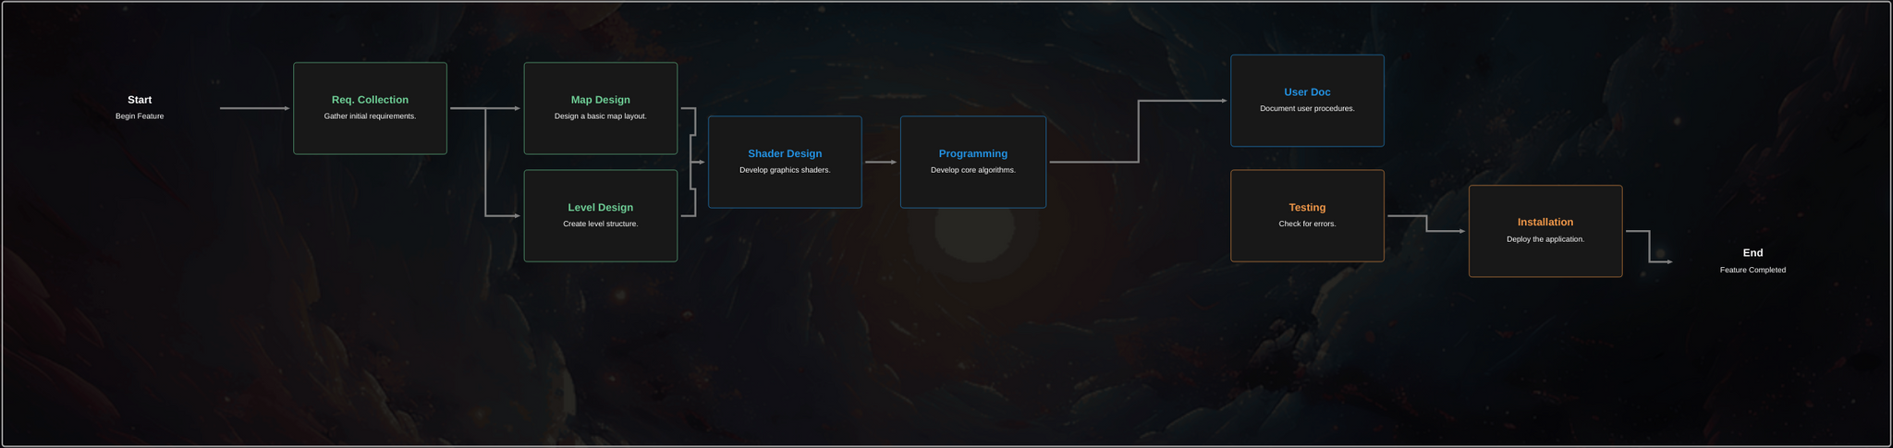

### Gantt timeline

| 1 |  |  |  |  |  |  |  |  |  |  |  |  |  |  |  |  |  |  |  |  |  |  |  |  |
| --- | --- | --- | --- | --- | --- | --- | --- | --- | --- | --- | --- | --- | --- | --- | --- | --- | --- | --- | --- | --- | --- | --- | --- | --- |
| 2 |  |  |  |  |  | 1 |  |  |  |  |  |  |  |  |  |  |  |  |  |  |  |  |  |  |
| 3 |  |  |  |  |  | 1 |  |  |  |  |  |  |  |  |  |  |  |  |  |  |  |  |  |  |
| 4 |  |  |  |  |  |  |  |  |  |  |  | 2,3 |  |  |  |  |  |  |  |  |  |  |  |  |
| 5 |  |  |  |  |  |  |  |  |  |  |  |  |  |  |  |  |  |  | 6 |  |  |  |  |  |
| 6 |  |  |  |  |  |  |  |  |  |  |  |  |  | 2,3,4 |  | 4 |  |  |  |  |  |  |  |  |
| 7 |  |  |  |  |  |  |  |  |  |  |  |  |  |  |  |  |  |  | 6 |  |  |  |  |  |
| 8 |  |  |  |  |  |  |  |  |  |  |  |  |  |  |  |  |  |  |  |  | 5,7 |  |  |  |
|  | 1 | 2 | 3 | 4 | 5 | 6 | 7 | 8 | 9 | 10 | 11 | 12 | 13 | 14 | 15 | 16 | 17 | 18 | 19 | 20 | 21 | 22 | 23 | 24 |